To get your started Please open TwinCAT System Manager
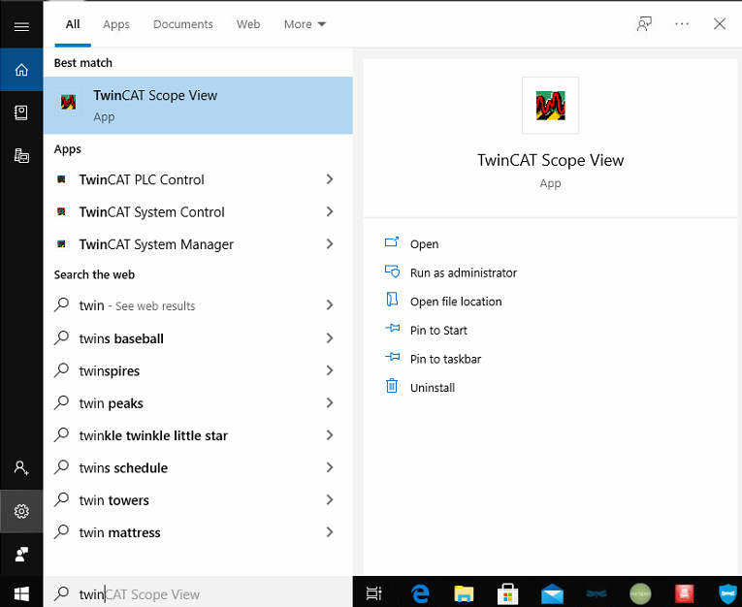

Then click twice on the address on bottom right corner
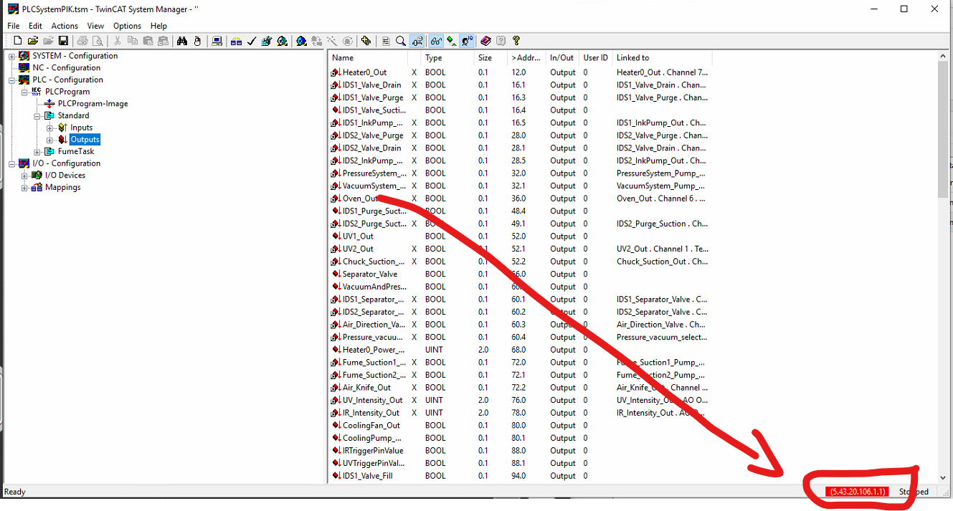
Now just copy this(the last) address!
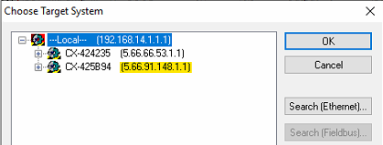
This is your IP address to use in the script.
In the script you must put the IP in this position:
